Modeling Architecture Patterns:

Patterns are found at various levels throughout the enterprise architecture. The purpose of this document is to focus on the patterns that exist in the structural artifacts of the enterprise architecture, which are commonly referred to as “primitives”. These are the building blocks (DNA if you will) for the logical construction of composites, functions, applications and eventually platforms.

Primitives vs. Composites
- Primitive models comprise architecture
- Composite models comprise implementations

 | Who | What | Where | How | Why | When
 | Resource | Content | Location | Process | Motivation | Time

Standards:

Standards exist around the core aspects of architecture to ensure we maintain the principles and supporting “ilities”. The core aspects include:
- Interfaces (connecting things to other things)
  - Human to machine
  - Machine to machine
  - Software to machine
  - Software to software
  - Human to software
  - Software to protocol
  - Protocol to protocol
  - Protocol to machine
- Metadata (provides us with the WHO, WHAT, WHERE, WHEN and HOW)
  - includes models
  - ontologies
  - taxonomies
  - dimensions (which includes master data)
- Rules (provides us with the WHY and directs functional “behavior” for Metadata instances)
  - includes relationships (direct & indirect)
  - transforms & mappings
  - compliance
  - analytics (predictive & reactive)
- Methodologies (provides us with consistency in describing & transition states so that we can understand where we are, where we want to be and plan change)
  - Lifecycle mgmt
    - Customer needs & requirements mgmt (customer focus)
    - Business needs & requirements mgmt (strategy)
    - Design, build & implementation (execution)
    - Gap Analysis
      - Six Sigma (continuous improvement)
      - Innovation (stepwise improvement)

- Components are specializations of classes and therefore have attributes and operations, but are also associated with provided and required interfaces. Finally components inherit indirectly from Encapsulated Classifier and thus may own ports that formalize their interactions points.
- Interfaces serve as contracts that components must comply with. An interface is either a provided interface that describes a set of functionalities offered by a component, or a required interface that describes a set of functionalities that a component expects from its environment.
- Ports specify a distinct interaction point between the component that owns the port and its environment, or between the component and its internal parts (properties). Ports may specify required and provided interfaces of the component that owns them.
- Connectors are either assembly connectors that connect the required interface of one component to the provided interface of a second, or delegation connectors that link the ports of a component to its internal parts.
- Packages are mechanisms for grouping model elements either by owning them or importing them. They also provide a namespace for uniquely identifying the elements by their name

- The subsystem shielded by a FACADE [11] is a group of those components belonging to the subsystem.
- The LAYERS pattern [6] divides the system into logical layers, each of them is a ‘virtual’ group of components.
- The components of a BROKER [6] architecture are a group of components working on the same task.
- An INDIRECTION LAYER [45] redirects invocations from one group of components into another.
- A VIRTUAL MACHINE [42] redirects invocations into a group of implementation layer components.
- An INTERPRETER [42,11] redirects script invocations into a group of implementation components.
- A MESSAGE REDIRECTOR [45] dispatches invocations into a group of components that form a subsystem.
- A BLACKBOARD [6,42] is accessed and modified by a group of Knowledge Sources.
- A MICROKERNEL [6] offers services by groups of internals and external servers.
- The REFLECTION pattern [6] allows a group of application- logic components to query a group of meta-objects in order for the former to abstract their structural and behavioral aspects.
- A PEER-TO-PEER [7] system groups peer components and relates different groups with each other.
- The PUBLISH-SUBSCRIBE pattern [6,7] offers asynchronous notification to a group of independent subscribers.

Callback
callback-structure is a key participant in the patterns, it cannot be explicitly modeled and
made visible in UML diagrams, such as component diagrams, class diagrams, or sequence diagrams.

Indirection
Indirection happens when one or more related ‘‘proxy’’components receive a message on behalf of one or more ‘‘target’’ components and forward the message to these ‘‘targets’’, perhaps after some computation has taken place. Afterward the result is sent back, again through the ‘‘proxy’’ components. Indirection can take place at small scale, with only one client, one proxy, and one target component. It can also involve multiple components playing the role of any of these participants. For instance, a whole layer or subsystem,
consisting of multiple components and connectors, might indirect invocations to other components.

Grouping
several design situations, a number of components belong semantically together, for instance because they fulfill a collective task. In some of these situations, designers want to model this concern explicitly using the object-oriented ‘‘part-of’’ (or aggregation) relationship

Layering
For instance, the most common rule is that an intermediate layer cannot be bypassed during an invocation from a higher layer to a lower layer. As in the Grouping primitive, a layered component structure should only contain components (and not other UML elements). Also, a layer is typically a virtual entity, i.e., in many cases it only exists to indicate a conceptual abstraction in the system. Hence, Layering builds upon the Grouping primitive and further constrains it. Specifically, it entails that group members from layer X may call into layer X 1 and components outside the layers, but not into layer X 2 and below.

Aggregation Cascade
A COMPOSITE [11] describes part–whole hierarchies where
a composite object is composed of numerous subparts.
Both composite and leaf components inherit from the same
class, and are treated uniformly by clients. For example a
GUI widget can call its parts to paint themselves, and they
call their parts and so on. A cascade [9] is a COMPOSITE
structure with (recursive) constraints of the form: ‘‘A composite
A can only aggregate components of type B, B only
C, etc’’.

Composition Cascade
A Composition Cascade builds upon Aggregation Cascade,
and further enforces that a component may not be
part of more than one composite at any time. In this case,
composites have a lifecycle responsibility for their parts.
That is, the whole may take direct responsibility for creating
or destroying the parts, or it may accept an already
existing part, and later pass it on to some other whole that
assumes responsibility for it.

Shield
In certain cases, a set of components cannot or should
not be accessed directly by clients. Instead, another intermediary
component is to be used to access the set of components.
The rationale behind this ‘shielding’ is usually
information hiding, separation of concerns, or the implementation
of central tasks which should be respected by
all the components in the set.
The Shield primitive captures this design rationale with
the following properties: One or more components act as
‘shields’ for a set of components that form a subsystem.
No external client should be allowed to access members
of the subsystem directly, but access should happen only
through these ‘shields’.

Typing
In many situations, the typing abstraction provided by
the design or programming language is not sufficient for
modeling domain types. For instance, the domain might
require dynamic or constrained type dependencies.
Consider for example a typical business situation: There
are different Party Types in a company (e.g. ‘‘manager’’,
‘‘implementation group’’), and a particular business entity
(e.g. John, group X) can change its Party Type at runtime:
A component of party type ‘‘manager’’ can become ‘‘senior
manager’’, a group of type ‘‘test group’’ can become
‘‘implementation group’’, and so forth. There are usually
constraints on these type changes (e.g. a group cannot take
a Party Type that needs to be fulfilled by a person).

Virtual Connector
In many patterns and larger architectures, components
have no direct relationship, but still communicate virtually
using other components and connectors in between. For
instance, in a layered distributed client/server architecture
a component on the client-side often virtually communi-
Fig. 16. Stereotypes for modeling Typing.
Fig. 17. The notation of the stereotypes in Typing modeling.
1020 U. Zdun, P. Avgeriou / Information and Software Technology 50 (2008) 1003–1034
cates with a component from the same layer on the serverside.

Broker architecture
a general
architectural configuration that separates a distributed system’s
communication functionality from its application
functionality by isolating all communication-related concerns.
A BROKER hides and mediates all communications
between the objects or components in a system. Local client-
side and server-side brokers enable the exchange of
requests and responses between the peers.

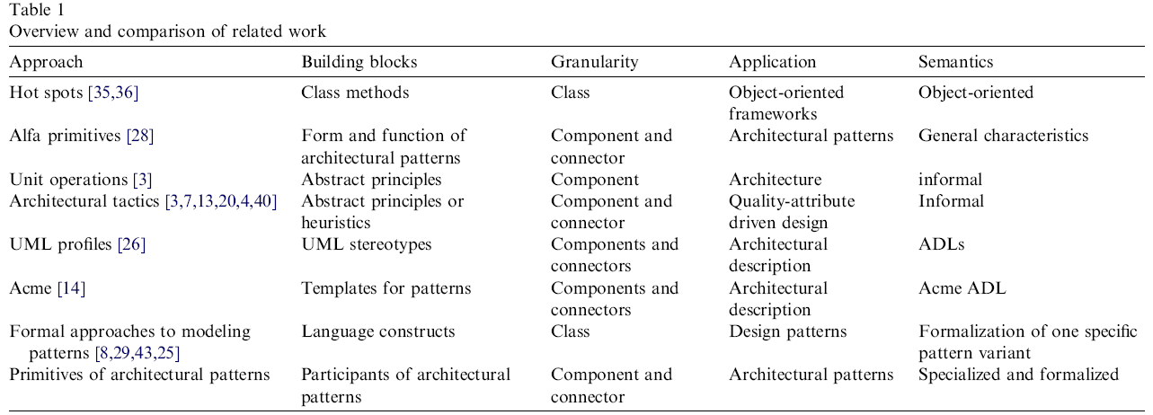

Architecture Patterns:

Pattern Name Frequency
Layers
Shared Repository
Pipes and Filters
Client-Server
Broker
Model-View-Controller
Presentation-Abstraction- Control
Explicit Invocation
Plug-in
Blackboard
Microkernel
Peer to Peer
C2
Publish-Subscribe
State Transition
Interpreter
Half Sync, Half Async
Active Repository
Interceptor
Remote Procedure Call
Implicit Invocation

Key quality attributes would
include performance, extensibility, security, and
availability.

Table 5: Frequency of Architecture Pattern Pairs
Pattern Pair Frequency
Layers – Broker 6
Layers – Shared Repository 3
Pipes & Filters – Blackboard 3
Client Server – Presentation
Abstraction Control 3
Layers – Presentation Abstraction Control 3
Layers – Model View Controller 3
Broker – Client-Server 2
Shared Repository – Presentation
Abstraction Control 2
Layers – Microkernel 2
Shared Repository – Model View Controller 2
Client Server – Peer to Peer 2
Shared Repository – Peer to Peer 2
Shared Repository – C2 2
Peer to Peer – C2 2
Layers – Interpreter 2
Layers – Client Server 2
Pipes & Filters – Client Server 2
Pipes & Filters – Shared Repository 2
Client Server – Blackboard 2
Broker – Shared Repository 2
Broker – Half Sync/Half Async 2
Shared Repository – Half Sync/Half Async 2
Client Server – Half Sync/Half Async 2

Many of the most common pairs seem to logically go
together, in particular, the following pairs:
1. The Layers – Broker connection is very
common among distributed applications. A
server is often implemented with Layers. The
Broker pattern coordinates communication
from remote clients. The patterns also have a
symbiotic relationship with respect to
security: layered systems often have an outer
authentication layer, while the Broker can
provide some protection against intrusion
attacks. Brokers may be implemented in
layers [27], and layered applications are
common in distributed communication (e.g.,
the ISO/OSI stack.)
2. The Broker and Client-Server patterns are a
natural pair for distributed applications. The
Client-Server pattern defines the relationship
between providers of services and consumers
of the services (clients.) Brokers coordinate
the communication between them. Broker is
also used to implement efficiency,
availability, and security, which are common
concerns in client-server systems.
3. A Shared Repository is obviously designed to
allow multiple access, but may need security
and some access restrictions. Layers are often
used to provide an interface to a Shared
Repository, and can thus provide the
necessary security and other screening of
requests.
4. Many interactive applications are designed as
layered systems. Management of the user
interface is often encapsulated in a separate
component, becoming the outer layer. The
user interaction can be managed using the
Model View Controller pattern, with the bulk
of the layered system becoming the Model,
and the interface (outer layer) managed with
the View and Controller. Alternatively, the
layered system can present an abstract
representation of the user interface
functionality for use with the Presentation
Abstraction Control pattern. Each of these
alternate user interface patterns was paired
with the Layers pattern three times.
5. The Presentation Abstraction Control pattern
was also paired with Client-Server three
times. Different clients may require different
presentations of the functionality from the
server. This can be accomplished by using the
Presentation component, with the Abstraction
and the Control residing with the server.
Other common pairs of patterns have less apparent
relationships, and further research is required to
determine their relationships. Possibly the combination
of patterns in some cases cannot be generalized, but
specific variants of patterns were combined to satisfy
individual system requirements.
In the pairs described above, some of the symbiosis
appears to be related to quality attributes, such as
performance, usability, and security. It appears that in
many cases, the patterns provide structure to
implement some functionality, but one pattern may
have particular impact on important quality attributes
of the system. For example, the Client-Server pattern
defines the basic structure, and the Broker pattern adds
some functional capabilities, but is particularly strong
in the quality attributes. It may be that some patterns
are selected primarily for their functional capabilities,
while others are selected in order to support quality
attributes. (We have observed this once in a system
design experiment, in which participants selected the
Layers pattern for functionality, and the Broker pattern
for availability and security [14].) While research into
the interaction among architecture patterns is in its
infancy, this may be an indicator of how architecture
patterns work together.

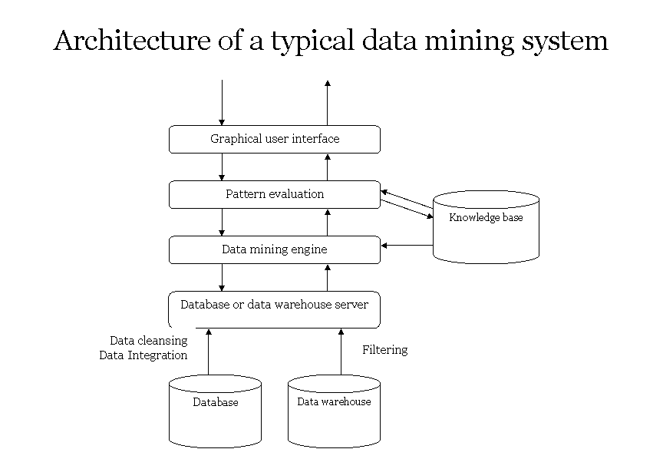

Attribute Driven Design

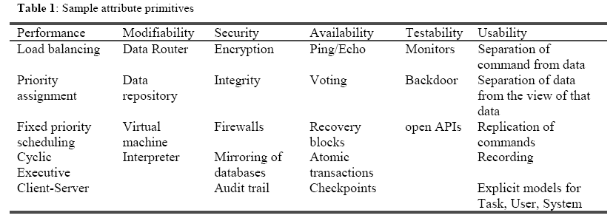

The functional drivers are derived from the abstract functional requirements (e.g. features) or concrete
functional requirements (e.g. use cases, list of responsibilities, etc.). Some criteria that can be used to group
functionality are:
1. Functional coherence. Requirements grouped together should exhibit low coupling and high cohesion.
This is a standard technique for decomposing function to support modifiability.
2. Similar patterns of data or computation behavior. Those responsibilities that exhibit similar patterns of
data and computation behavior should be grouped together, e.g. accessing a database in a similar
fashion. This will support future performance considerations.
3. Similar levels of abstraction. Responsibilities that are close to the hardware should not be grouped with
those that are more abstract. This will support modifiability.
4. Locality of responsibility. Those responsibilities that provide services to other services should not be
grouped with purely local responsibilities. This will support reusability of services.

Patterns:

- In the OBSERVER pattern [11] an observer component is notified by one or more subjects about state changes and other events. Usually the notification is realized as a callback.
- MODEL-VIEW-CONTROLLER [6] uses callbacks to inform views about changes in the model, much like the logic behind the OBSERVER pattern.
- A REACTOR [39] is a special kind of OBSERVER that is informed about network events using callbacks.
- In the EVENT SYSTEM pattern [42] components may broadcast a number of events. Another component may register an interest in an event by associating a callback with the event. When an event occurs, the EVENT SYSTEM dispatches all the callbacks associated with the event.
- There are various patterns describing interception architectures, such as INTERCEPTOR [39], MESSAGE INTERCEPTOR [45], and INVOCATION INTERCEPTOR [44]. Interceptors are invoked as extensions to some other invocation; thus they must be invoked, when this other invocation takes place. Usually, the interceptors are triggered by callback events like ‘invocation arrived’ or ‘invocation finished’.
- VISITORS [11] are used to define an interpretation mechanism apart from the structure to be interpreted. They are usually called back, by the elements to be visited.
- An INDIRECTION LAYER [45] is a general pattern describing a LAYER [6] that redirects all invocations from one system context into another.
- Ordinary LAYERS [6] redirect invocations from layer X to the layer beneath, X 1.
- A VIRTUAL MACHINE [42] redirects invocations from a byte-code layer into an implementation layer for the commands of the byte-code.
- An INTERPRETER [42,11] redirects invocations from a script (interpreted code) layer into an implementation layer for the commands of the script (interpreted code).
- An ADAPTER [11] redirects invocations from one interface to another.
- FACADE [11] shields a subsystem and redirects invocations into that subsystem.
- A PROXY [11] is a placeholder of another object and redirects invocations to that object.
- A CLIENT PROXY [44] is a special PROXY in the distributed system context.
- A COMPONENTWRAPPER [47] wraps a component and redirects invocations to that component.
- WRAPPER FACADE [39] wraps a procedural library, and redirects invocations to that library.
- AMESSAGE REDIRECTOR [45] is a component whose task it is to redirect (dispatch) invocations for a subsystem.
- The subsystem shielded by a FACADE [11] is a group of those components belonging to the subsystem.
- The LAYERS pattern [6] divides the system into logical layers, each of them is a ‘virtual’ group of components. The components of a BROKER [6] architecture are a group of components working on the same task.
- An INDIRECTION LAYER [45] redirects invocations from one group of components into another.
- A VIRTUAL MACHINE [42] redirects invocations into a group of implementation layer components.
- An INTERPRETER [42,11] redirects script invocations into a group of implementation components.
- A MESSAGE REDIRECTOR [45] dispatches invocations into a group of components that form a subsystem.
- A BLACKBOARD [6,42] is accessed and modified by a group of Knowledge Sources.
- A MICROKERNEL [6] offers services by groups of internals and external servers.
- The REFLECTION pattern [6] allows a group of application- logic components to query a group of meta-objects in order for the former to abstract their structural and behavioral aspects.
- A PEER-TO-PEER [7] system groups peer components and relates different groups with each other.
- The PUBLISH-SUBSCRIBE pattern [6,7] offers asynchronous notification to a group of independent subscribers.
- The LAYERS [6] and LAYERED SYSTEM [42] patterns described layered structures.
- An OBJECT SYSTEM LAYER [47] introduces a layer hosting a object system as an extension of the language in which the OBJECT SYSTEM LAYER is implemented.
- INDIRECTION LAYER [45] describes LAYERS [6] that redirects all invocations in one system context into another.
- A MICROKERNEL [6] is structured in three layers: external servers, the microkernel, and internal servers.
- The PRESENTATION-ABSTRACTION-CONTROL pattern also enforces layers: a top layer with one agent, several intermediate layers with numerous agents, and one bottom layer which contains the ‘leaves’ agents of the tree-like hierarchy.
- The COMPOSITE [11] pattern describes general composite structures. Our primitive concerns especially design situations with multiple composite structures that are interconnected or recursive (and may have additional constraints).
- A CASCADE [9] is a COMPOSITE structure with (recursive) constraints of the form: ‘‘A composite A can only aggregate components of type B, B only C, etc’’.
- ORGANIZATION HIERARCHY [10] is an analysis pattern that requires both composite constraints and (recursive) constraints of the form: ‘‘A composite A can only aggregate components of type B, B only C, etc’’. Such analysis patterns are frequently realized by component architectures.
- Composition Cascade has the same known uses in patterns as Aggregation Cascade: COMPOSITE [11], CASCADE [9], and ORGANIZATION HIERARCHY [10]. The difference to the Aggregation Cascade known uses is that the patterns are realized using aggregation relationships that assume lifecycle responsibility for the parts.
- The subsystem shielded by a FACADE [11] often should not be accessed directly, but only via the FACADE.
- In the LAYERS pattern [6], often layers should not get bypassed, i.e., lower-level layers should not be accessed directly. Also, often layer elements should only be accessed via the layer’s interface. Hence, the layer’s interface shields the layer’s elements and other lower level layers.
- The INDIRECTION LAYER [45] shields the ‘‘target’’ component from the client.
- A MESSAGE REDIRECTOR [45] is a component whose task it is to redirect (dispatch) invocations for a subsystem. It should usually not get bypassed.
- In the REFLECTION pattern [6], the meta-object protocol shields the meta-objects from the client component.
- A VIRTUAL MACHINE [12] shields the platform details in order for the byte-code to be ported in different platforms.
- An OBJECT SYSTEM LAYER [47] introduces a layer hosting a object system as an extension of the language in which the OBJECT SYSTEM LAYER is implemented. The objects in the OBJECT SYSTEM LAYER should only be accessed through the OBJECT SYSTEM LAYER’S interface.
- Many remoting patterns [44] used in a layered BROKER architecture shield a whole subsystem realizing their functionality: The subsystem’s should not be accessed directly.
- The pattern TYPE OBJECT [21] resolves the problem that a certain type relationship has to be dynamic in a statically typed, object-oriented language. By building the type relationship with the objects of the language, instead of the static classes, dynamic typing is ‘‘simulated’’ using delegation.
- A common example of an extension of the TYPE OBJECTS [21] pattern are analysis pattern that realize a KNOWLEDGE LEVEL [10], a meta-level architecture for typing in the sense of TYPE OBJECT. We give below the examples of party types and accountability types
- An OBJECT SYSTEM LAYER [47] introduces a layer hosting a object system as an extension of the language in which the OBJECT SYSTEM LAYER is implemented. Thus a whole custom type system is introduced with in the OBJECT SYSTEM LAYER.
- The client-side components and the server-side components of a BROKER [6] communicate virtually among each other.
- Many remoting patterns [44] virtually communicate with each other, for instance: client and server INVOCATION INTERCEPTORS, REQUESTOR and INVOKER, client and server MARSHALLERS, CLIENT and SERVER REQUEST HANDLER, and client and server PROTOCOL PLUG-INS.
- PROXIES [11] often use intermediate components and thus virtually communicate with their target. For instance, remote PROXY [6] use a BROKER [6] to access the remote target.

